Calne Running Club
Clothing List

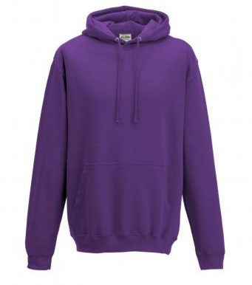
Hoodie (AWDis) £18.10, colour purple, includes Calne Running Club printed left chest & back.
Size: | XS | S | M | L | XL | XXL | 3XL
Chest (to fit): | 34 | 36 | 40 | 44 | 48 | 52 | 56

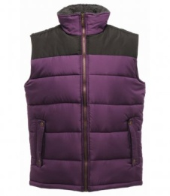
Bodywarmer (Regatta) £26.40 , colour purple, includes Calne Running Club embroidered left chest.
Size: | XS | S | M | L | XL | XXL
Chest (to fit): | 35/36 | 37/38 | 39/40 | 41/42 | 43/44 | 46/48

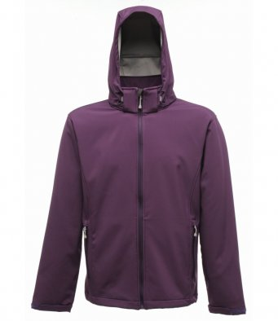
Soft Shell Jacket (Regatta) £32.05, colour purple, includes Calne Running Club embroidered left chest and Back.
Size: | XS | S | M | L | XL | XXL
Chest (to fit): | 35/36 | 37/38 | 39/40 | 41/42 | 43/44 | 46/48
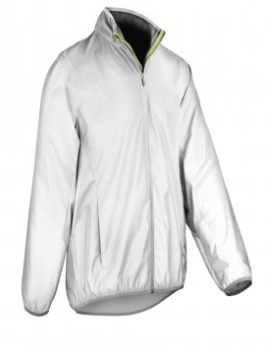
Reflective Jacket (Spiro) £33.35, includes Calne Running Club print left chest.
Size: | XS | S | M | L | XL | XXL | 3XL | 4XL
Chest (to fit): | 36 | 38 | 41 | 44 | 47 | 50 | 53 | 56

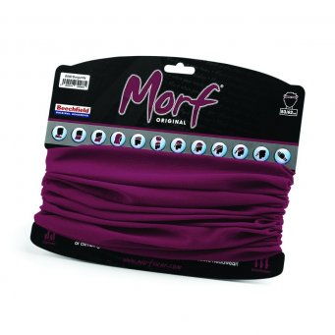
Morf £4.65, colour purple, includes Calne Running Club print.

