CALNE
RUNNING CLUB

www.calnerunningclub.co.uk
Established 1992 England Athletics Affiliated
Contact: secretary@calnerunningclub.co.uk
Membership Form 2018
Club Ethos:
Our aim is for running to be an inclusive and enjoyable leisure activity offering the opportunity to improve mental and physical health and fitness.
Members may also choose to compete in club and county championships and other races and the training provided will support members who do this.

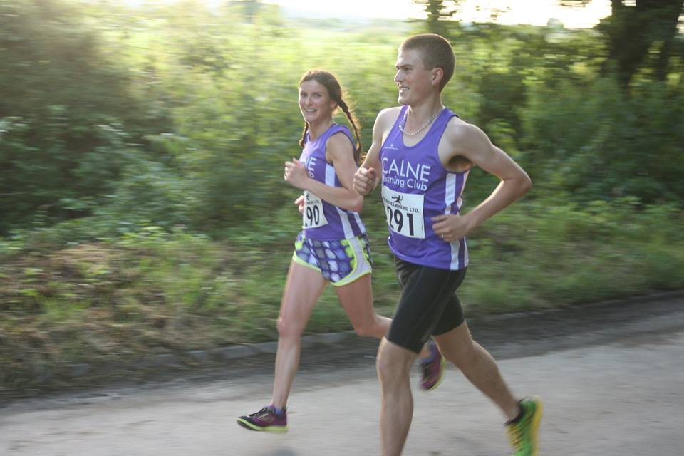
When and where to meet:
Training is twice a week; on Tuesdays and Thursdays, from 19.00 to 20.00. Please be at Beversbrook Sports Centre ten minutes earlier to ensure the session can start promptly.
Tuesday evenings are social runs with three different groups going out according to the speed of the runners. Each group is led by a qualified run leader. In the summer there are sometimes other runs on these evenings so keep a look out for changes.
Thursdays evenings are more structured sessions to develop speed and endurance and are usually led by one of our qualified coaches. In summer they are generally on the field at Beversbrook and in winter on a quiet road in the nearby industrial estate.
Notes about the sessions are put on our closed Facebook page. Please email the secretary if you do not use Facebook and we can email you the posts should there be any important information you need.
Club Colours:
There is no obligation to purchase any club clothing but many members choose to wear them, especially when taking part in races. If you would like to buy a Ronhill vest or t-shirt please ask Denise - other kit is also available.

Club Championships:
A list of events, ranging from 5k to ultra-marathon races that make up the club championship is available on the website. Members will need to inform the club if they have taken part in an event so the results can be collated.

In addition to running:
Many of our members are also tri-athletes, ultra-marathon runners, ironman finishers and ‘moonwalkers’. Please speak to our coaches and they will point you in the right direction for tips and advice and can help with training plans tailored to suit your individual goals!

Youth Policy:
We are able to coach runners over the age of 12, but as we do not have a dedicated child protection officer anyone under 18 must be accompanied by an adult who is responsible for them.

Health and Safety:
As with any sport it is important that you warmup/down appropriately to avoid injury. Suitable clothing and footwear are also important. High viz clothing and lights are important when running particularly during winter evening runs. Road safety is the responsibility of individual runners.
Please read the following information before completing the form:
When you become a member of or renew your membership with Calne Running Club you will automatically be registered as a member of England Athletics. We will provide England Athletics with your personal data which they will use to enable access to an online portal for you (called myAthletics). England Athletics will contact you to invite you to sign into and update your MyAthletics portal (which, amongst other things, allows you to set and amend your privacy settings). If you have any questions about the continuing privacy of your personal data when it is shared with England Athletics, please contact dataprotection@englandathletics.org.

Within the club your data is shared only with the club committee, coaches and run leaders as deemed appropriate.
Results of timed events within the club may be published on the website or via a results website. If you do not wish results to be published you will need to ensure the appropriate people are informed and check that this is an option.
CALNE
RUNNING CLUB

Full Name……………………………………………………………………………………………………….
Address:………………………………………………………………………………………………………….
………………………………………………………………………………………………………………………..
Postcode:………………………………………………. DOB: …………………………………………………
Tel:........................................................... Mobile: …………………………………………………..
Email:………………………………………………………………………………………………………………………….
Please ensure email addresses are written clearly if completing by hand.

If you are a member of another running/athletics club please list the names(s) and state whether you are a 1st or 2nd claim.
Name of Club: …………………………………………………………………Claim………………………..
Name of Club: …………………………………………………………………Claim………………………..
Information contained on this form will not be shared unless you have given prior permission.
Please return this form, with £25, to Celia Stevens (Club Secretary).
I agree that I will abide by the highway code at all times and I understand that run and take part in any training run at my own risk. I accept that there are risks in taking part in each training session and I also agree that no person(s) or organisation will be held responsible for any accident, injury or loss to myself prior to, during, or after each training session. I understand that I should always speak to my doctor if I alter any element of my lifestyle including physical activity and exercise. Reading health and exercise information online may be helpful, but it cannot replace the professional diagnosis and treatment you might need from a qualified healthcare provider. I understand that the committee reserve the right to alter arrangements and conditions should circumstances require.
Signed:………………………………………………………………………………………………………….

